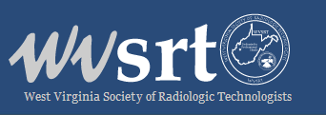

December 8, 2020

WVSRT Members-

This is an URGENT CALL TO ACTION to address new legislation introduced in the United States Congress impacting Medicare reimbursement specifically for Medical Imaging and Radiation Therapy.

Congress can immediately alleviate Medicare Reimbursement cuts by enacting H.R. 8702. Representative Mooney is a current co-sponsor.

If Congress fails to act, Radiology, Radiation Therapy, and Medical Imaging communities will be impacted in a severe and real way. That is why H.R. 8702 is so important to the every Imaging Professional.

By creating a two year “hold harmless” payment that essentially would keep the reimbursement rates for Medicare services at the 2020 amount, H. R. 8702 allows the Medical Imaging and Radiation Therapy community to review the losses that COVID-19 has caused and regroup after the full extent of the pandemic is analyzed.

We urge you to take immediate action to raise your voice by contacting the Congressional leaders for your district to voice support of H. R 8702.

The ASRT has made this an easy process:

- Log into the ASRT Website - ASRT Advocacy Action Center;

- Use the “Urgent Need to Enact H.R. 8702” form on the ASRT Advocacy Center to submit your support; and,

- Monitor the ASRT Advocacy Action Center for updates.

