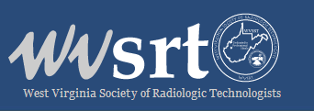

December 18, 2020

WVSRT Members-

This is an URGENT CALL TO ACTION to address new legislation introduced in the United States Congress impacting Medicare reimbursement specifically for Medical Imaging and Radiation Therapy.

The US Senate can immediately alleviate Medicare Reimbursement cuts by enacting the companion legislation for H.R. 8702, S. 5007.

If the Senator and Congress fail to act, Radiology, Radiation Therapy, and Medical Imaging communities will be impacted in a severe and real way. That is why H.R. 8702 and S. 5007 together are so important to the every Imaging Professional.

We urge you to take immediate action to raise your voice by contacting the Congressional leaders for your district to voice support of H. R 8702 and S. 5007.

The ASRT has made this an easy process:

- Log into the ASRT Website - ASRT Advocacy Action Center;

- Use the option to contact your US Senator form on the ASRT Advocacy Center to submit your support; and,

- Monitor the ASRT Advocacy Action Center for updates.

