2015 Annual Governance & House of Delegates Meeting
Albuquerque, NM

West Virginia Representation:
Teresa Snyder, Delegate
Michelle Eye, Delegate
Jackie Johnston, Alternate Delegate
Jeff Adkins, Alternate Delegate

The mission of the American Society of Radiologic Technologists is to advance the medical imaging and radiation therapy profession and to enhance the quality of patient care.

The ASRT is governed by an elected Board of Directors that is responsible for ensuring that ASRT's operations align with its strategic plan. The Board also approves budgets, sets strategic direction and hires the chief executive officer. Seven ASRT members serve on the Board of Directors.

The House of Delegates is the legislative body of the ASRT. It establishes professional standards of practice. It is composed of four delegates from each ASRT chapter, two delegates from each ASRT affiliate society and six delegates from all branches of the military. (asrt.org)

The Educational Symposium held prior to
the meeting was a great way to attain
continuing education credits. Six category
A+ CE credits were possible. There was
also a student tract available for the students
in attendance.

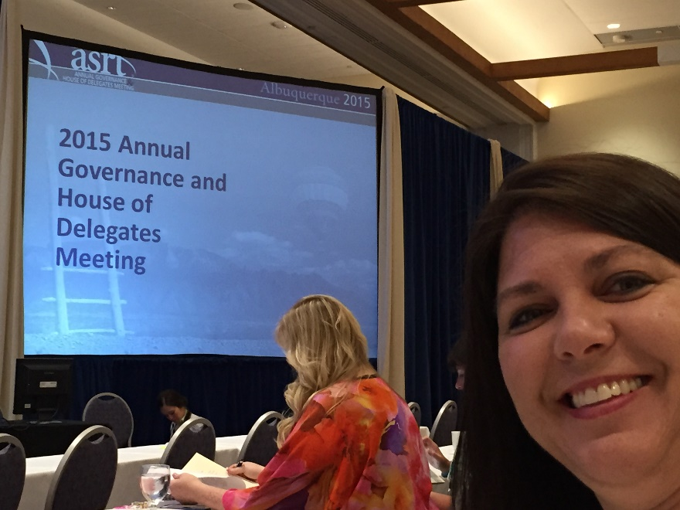
Michelle Eye

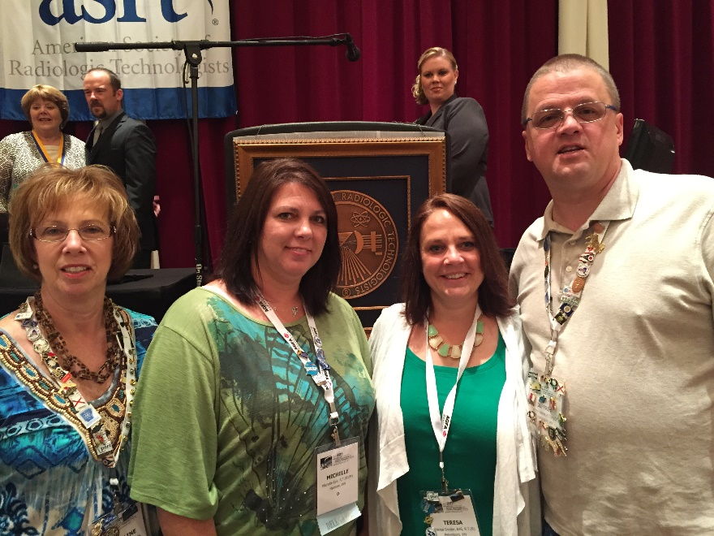
Saturday, June 27, 2015

Bylaws Open Forum
Commission Hearing
Chapter Meetings

Jackie Johnston, Michelle Eye,
Teresa Snyder, Jeff Adkins

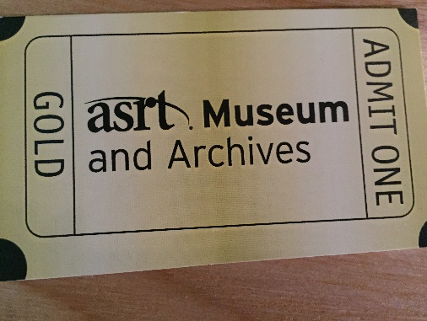
Saturday evening was the grand opening of the ASRT Museum and Archives!!

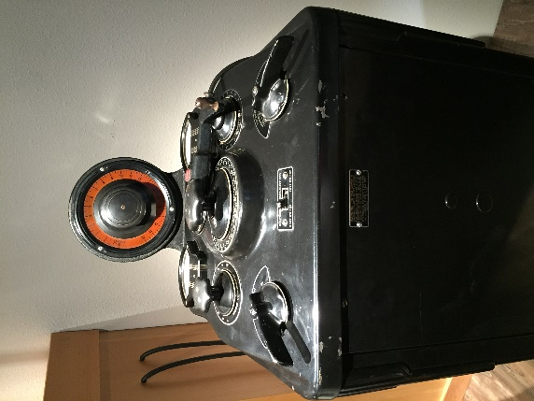
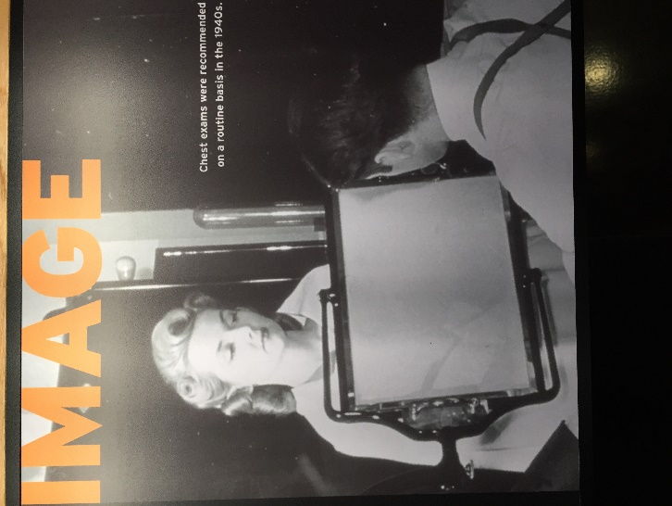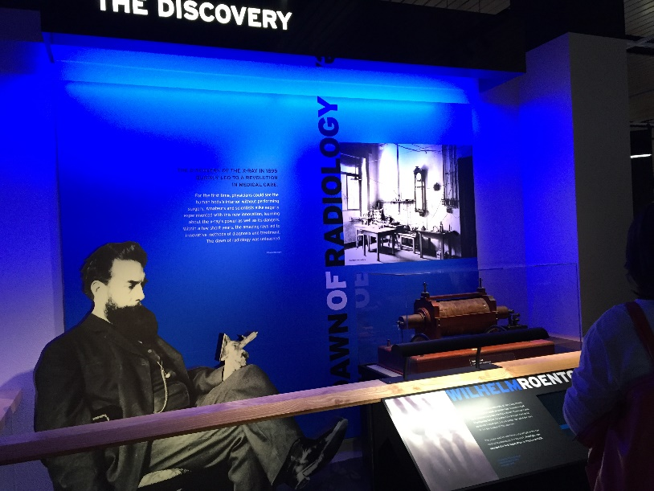
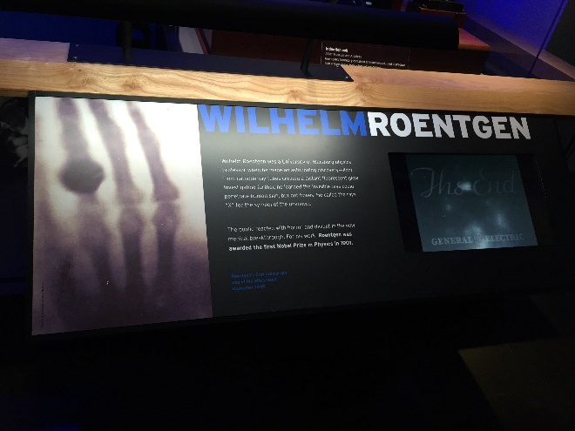
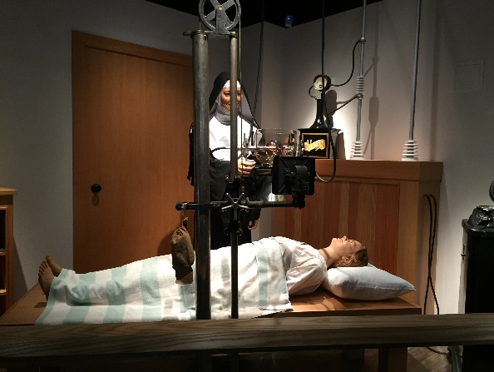

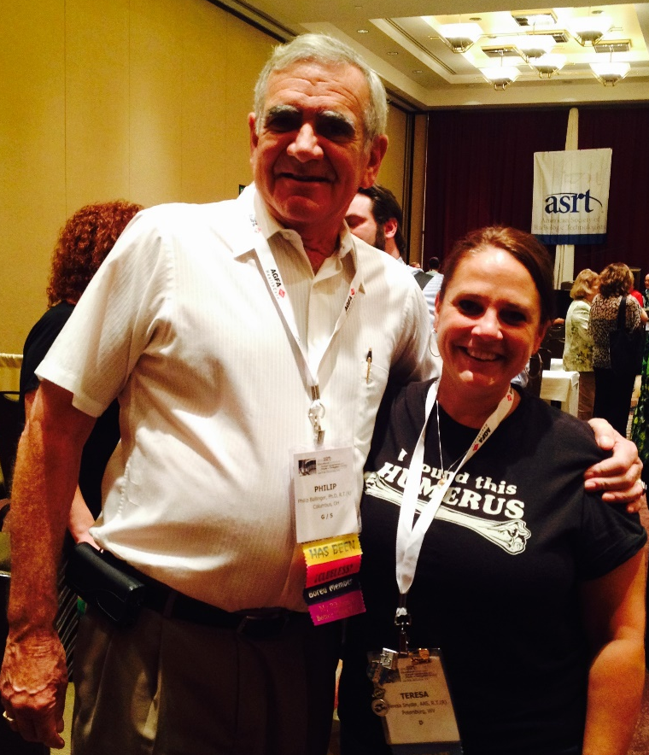
Teresa Snyder and Phil Ballinger

Sunday June 28, 2015
House Elections:
Speaker of the House : Mike Odgren
Vice-Speaker of the House: Beth Weber
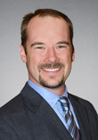
Mike Odgren Beth Weber

Student Leadership Academy
ASRT also sponsors a Student Leadership
Development Program which enables students
to learn about the profession through networking,
classroom activities and taking part in discussions.
This is a competitive process with an essay and
Academic requirements for selection.

Two students were chosen from West Virginia:
- Auston Jordan, St. Mary’s School of Medical Imaging
- Janeen Heath, WV Northern Community College Auston and Janeen during
flag ceremony…
Congratulations Auston and Janeen!

Leadership Academy
The ASRT Leadership Academy provides education on important principles of leadership and association management and provides knowledge to increase volunteer aptitude.

WVSRT’s Jeff Adkins was selected as a participant in the 2014 Leadership Academy and attended graduation at ASRT’s 2015 meeting in Albuquerque, NM. Congratulations Jeff!

It was an honor and a privilege to represent the technologists of the state of West
Virginia at the ASRT’s 2015 Educational Symposium and Annual Governance & House of Delegates Meeting. It was a great experience. I would encourage all technologists to attend this meeting if given the chance, it truly is a worthwhile experience!

Thank you to the West Virginia Society of Radiologic Technologists for affording us this opportunity!

Respectfully Submitted,

Teresa Snyder, Michelle Eye
2015 WVSRT Delegates

